Problem-01: Write a Program to test Default Constructor.

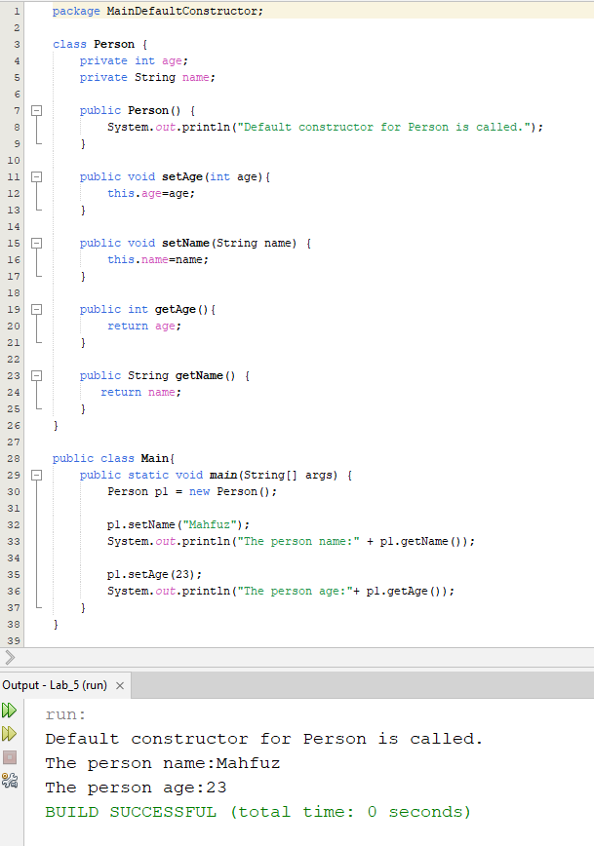

Problem-02: Write a Program to test Parameterize Constructor.

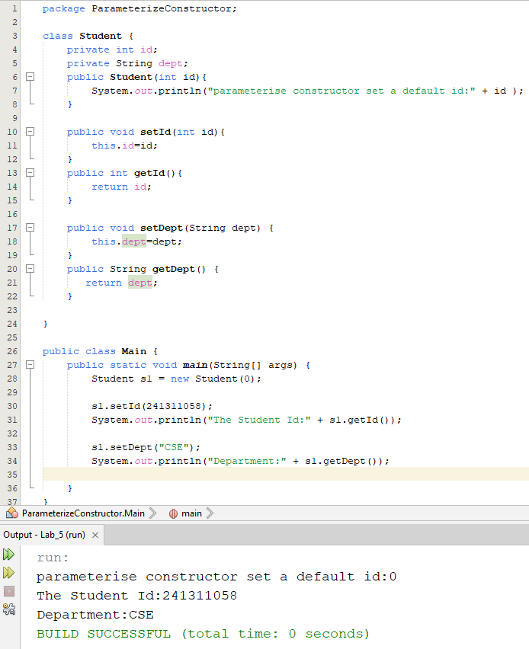

Problem-03: Write a Program to test Encapsulation.

